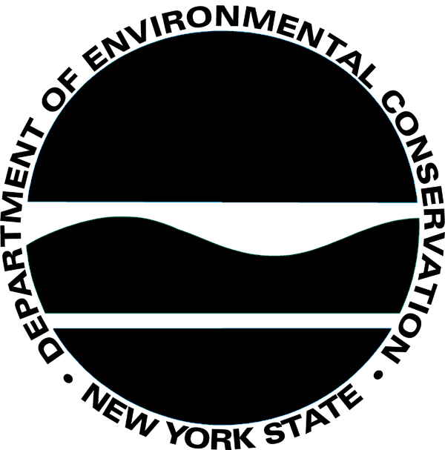

APPENDIX III - VOLUNTEER APPLICATION

New York State Department of Environmental Conservation
Stewardship Agreement

Name: (First, MI, Last) |  | Telephone:  (Home/Cell)
Address: (No. and Street) |  | Email Address:
City, State, Zip Code:
If a volunteer is working with minors or will be driving to perform activities as outlined in the Stewardship Agreement they must fill out the questions below about criminal convictions. All other volunteers may skip this section.

☐ Yes ☐ No |  | Have you ever been convicted of any crime (felony or misdemeanor)?
☐ Yes ☐ No |  | Are you currently under charges for any crime?
If you answered “yes” to either of the above questions, please explain under “Remarks or additional information” section or attach a separate sheet. None of the above circumstances represents an automatic bar to volunteer for work. Each case is considered and evaluated on individual merits in relation to the duties and responsibilities of the position(s) for which you are applying.
IN CASE OF EMERGENCY - PLEASE NOTIFY THE FOLLOWING PERSON:
Daytime
Name: _______________________________ Telephone Number ___________________________________
Are You Under 18 Years of Age? (If yes, a parent or guardian must sign below.) |  |  |  |  | ☐Yes ☐No |  |  | Date of Birth: | / /
PARENT/GUARDIAN PERMISSION (If Volunteer is under 18 years of age)
Print Name: |  |  |  | Signature:
Relationship to Volunteer: ____________________________ |  |  |  | Date: |  | ______________
I certify that the answers on this Volunteer form are correct to the best of my knowledge and belief and that a false statement knowingly made may be considered cause for termination of volunteer service.

Volunteer’s Signature: | _________________________________________________ | Date: | ________________

- The Steward initiator must verify the volunteer’s identity before signing and submitting this application to the Department.
- A photocopy of the volunteer’s driver license must be attached to this application if the volunteer will be driving a state or personal vehicle to perform activities as outlined in the Stewardship Agreement.
Stewardship Agreement Name |  | Agreement ID Number
Initiated by: (individuals authorized in the agreement)
Signature: _________________________________________ Date ______________________
DEC Respective Management Authority or his/her designee

Signature __________________________________________ Date ______________________

Remarks or additional information: ☐ Additional information is attached

Requests for reasonable accommodations necessary to insure full participation in our interview and selection process should be addressed to the Affirmative Action Officer, 625 Broadway, Albany, New York 12233.
THE NEW YORK STATE DEPARTMENT OF ENVIRONMENTAL CONSERVATION DOES NOT DISCRIMINATE ON THE BASIS OF RACE, COLOR, NATIONAL ORIGIN, GENDER, RELIGION, SEXUAL ORIENTATION, AGE, MARITAL STATUS OR DISABILITY IN EMPLOYMENT OR PROVISION OF SERVICES.
This form must be completed for each volunteer. Completed volunteer application forms must be forwarded to the Respective Management Authority or his/her designee who will maintain copies of completed volunteer applications for the life of the Agreement, plus 3 years. The information on this form is necessary to be certain that volunteers are covered by the Workers’ Compensation.

Volunteers are defined by 1) individuals performing tasks traditionally reserved for volunteers, i.e., they are not being used to supplant paid staff in performing staff activities; 2) the individuals are not being required to work certain hours or perform duties involuntarily; and 3) the individuals receive no remuneration for their activities. Volunteers under 18 years of age are not required to obtain employment certificates (working papers).

Questions concerning this form may be directed to the DEC contact person.
PERSONAL PRIVACY PROTECTION NOTIFICATION
The information you are providing on this application is being requested to meet the Department’s legal obligations. It will be used in accordance with Section 96 of the Public Officers Law. Failure to provide the requested information may result in your disqualification as a volunteer. The information will be maintained by the Director of Personnel, Department of Environmental Conservation, 625 Broadway, Albany, New York 12233 (518) 402-9273.

Page 2 (5/13)

